Name: _____________________ /65


Yr 12 ATAR Physics Electromagnetism Test 2018

Instructions
- Answer all questions in the spaces provided.
- Give all numerical answers to three significant figures, except where you are required to estimate values where two significant figures will be appropriate.
- Show all working – marks may be awarded for logical working even when an incorrect final answer is arrived at.
- Up to four marks may be deducted for incorrect significant figures and / or units.

QUESTIONS
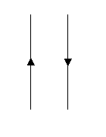
1. Two current carrying wires are set up as shown.
  - Draw in the field around each wire using ‘x’ or ‘•’. (1 mark)
  - What will happen to the wires when direct current flows in each wire as shown? (No explanation required.) (1 mark)

_________________________________________________
_________________________________________________

- Draw the field around the following magnets. (2 marks)

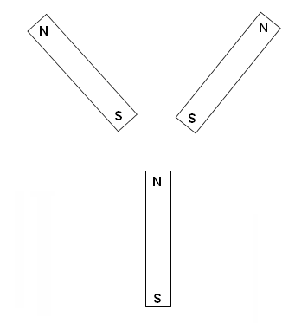

- Imagine you are driving East in a truck where the vertical component of the Earth’s magnetic field is 5.00 x 10⁻⁵ T upwards. If the axle of the truck is 2.45 m long, and the truck is travelling at 90.0 kmh⁻¹
- calculate the emf generated in the axle. (2 marks)

- which hemisphere are you driving the truck in? Explain. (2 marks)

______________________________________________________________________________________________________________________________________________________
___________________________________________________________________________
- The coil ABCD, which is free to rotate about the axis XY, is placed in a magnetic field of 9.08 mT. The coil consists of 25 turns and a current of 2.20 A is passing through it. The coil is rectangular, with AB = 55.0 mm and BC = 35.0 mm.
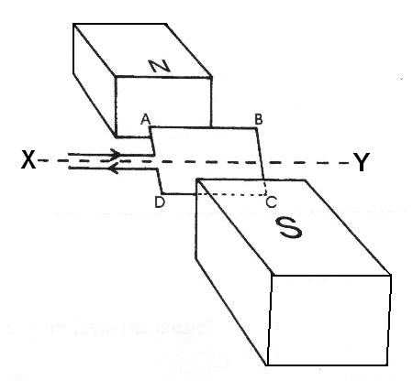
a. Calculate the maximum torque of the motor. (3 marks)

- Give three ways in which the torque could be increased. (3 marks)

________________________________________________________________________
________________________________________________________________________
________________________________________________________________________

- On the graph below, sketch the torque on the coil as it rotates through 360⁰ from being initially horizontal. (1 marks)

τ

θ
- A transformer is being tested. The primary coil is connected to a battery and a switch. The switch is closed allowing current to flow to the primary coil. An ammeter is connected to the secondary coil and initially deflects to the right then returns to its normal position.
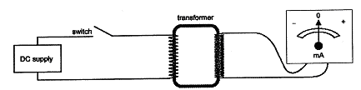

    - Explain why the meter needle deflected when the switch is initially closed.
(3 mark)

________________________________________________________________________________________________________________________________________________________________________________________________________________________________________________________________________________________________________________________________________________________________________________________________________________________________________________________________________________________________________________________________________________________________________________________________________________________________________________________________________

    - Explain why the needle returns to the original position even though the switch remains closed. (2 marks)

_____________________________________________________________________________________________________________________________________________________________________________________________________________________________________________________________________________________________________________________________________________________________________________________________________________________________________________________

- A coil has 400 turns with each of the coils having an area of 15.0 cm². The coil is placed in a magnetic field of flux density 0.800 T. What emf will be induced in the coil if the direction of the magnetic field is reversed in 2.45 s? (3 marks)

N S

The above diagram shows a conductor sitting in a magnetic field.

- If the conductor is allowed to fall, a current will be induced into it. Explain why.
(3 marks)
________________________________________________________________________________________________________________________________________________________________________________________________________________________
________________________________________________________________________________________________________________________________________________________________________________________________________________________

- If the conductor is connected to a battery and a current flows through it, then the conductor will move. Explain why.
(3 marks)
________________________________________________________________________________________________________________________________________________________________________________________________________________________
________________________________________________________________________________________________________________________________________________________________________________________________________________________

- Below is a side view of a DC motor with one coil. The poles of the magnet and the direction of the current are shown. (3 marks)

N
S
x

- Draw the magnetic field associated with the magnet below.
N
S

- Draw the magnetic field associated with each side of the coil.

x

- On the first diagram, draw the net magnetic field from both the magnets and the coil. Indicate the direction of the force on the sides of the coil.
- The motor in the previous question is changed so that it is now a generator and moved through the magnetic field as shown. (3 marks)
S
N

- Indicate with a dot and a cross, the direction of the induced current
- Show the overall magnetic fields from the magnets and the induced current.
- Indicate the direction of the force due to the induced current.

- Pylons supporting high voltage (e.g. 400 kV) transmission cables tend to be very high and located away from populated areas.

- Apart from stopping people from touching them, why give one additional reason (related to the unit) as to why they might be located high up and away from populated areas?
(1 marks)
________________________________________________________________________________________________________________________________________________

- Give two reasons why electrical power is transmitted at very high voltages such as 400 kV?
(2 marks)
_____________________________________________________________________________________________________________________________________________________________________________________________________________________________________________________________________________________________________________________________________________________________________________

- A small country town uses a 150.0 kW gas powered generator to provide its electricity needs. The generator provides a voltage of 1000 V. This voltage is stepped up to 10 000 V to minimise power losses. The generator is located 5.00 km away from the town and the power lines that link the generator to the town have a total resistance of 2.00 ohms. At the edge of town, the voltage is stepped down to 250 V again. (The transformers are 100% efficient)
- Calculate the current that will flow through the power lines. (2 marks)

- How much power is lost in the lines as heat? (2 marks)

- Due to the loss of power, the voltage is reduced. Calculate the voltage drop along the lines. (2 marks)

- Consider the diagram of the transformer shown below.
a) If the input voltage was 270 V, what would be the output voltage? (2 marks)

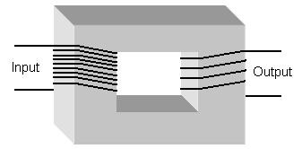

b) Eddy currents created in the iron core can reduce the efficiency of transformers. Explain what eddy currents are, how they are formed and design features of real transformers that minimise eddy current production. (4 marks)

- Below is a photograph of a brick saw on a stand. The saw is powered by a 2.2 kW single phase AC electric motor that draws current from the 240 V and 50 Hz mains supply. There is a very tight belt around the shaft of the blade and the shaft of the electric motor and this is how the spinning motor makes the blade spin. Bricks are cut by placing them on the platform and pushing them through the spinning blade.
Motor

Spinning blade

Platform
- Calculate the current used by the saw when it is operating normally. (2 marks)

- Calculate the size of the EMF generated by the coil if the supply is exactly 240 V and the losses due to inefficiency are 28 V. (1 mark)

- When the motor is switched on, it speeds up until it reaches a maximum. Explain how the EMF generated in the coil restricts the speed of the motor. (4 marks)

________________________________________________________________________
________________________________________________________________________
________________________________________________________________________
________________________________________________________________________
________________________________________________________________________
________________________________________________________________________
________________________________________________________________________
________________________________________________________________________
________________________________________________________________________
________________________________________________________________________
________________________________________________________________________
________________________________________________________________________

- An electron is placed in an electric field between two parallel plates that are 3.00cm apart and have 1500V across them, as in the diagram below.
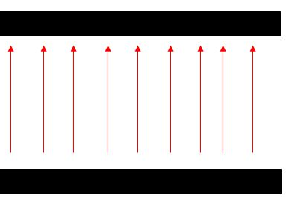

a) Determine the electric field intensity. (1 mark)

b) Determine the final velocity of the electron as it moves through the gap in the positive plate. (3 marks)

The electron is then directed into a strong magnetic field, as shown below.

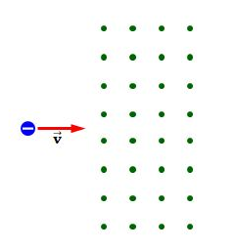
c) On the diagram above, show the direction of the force experienced by the electron.
(1 mark)

d) Determine the radius of curvature of the electron if the magnetic field intensity is 2.10T and the electron’s entry velocity is that which you determined in (b). (3 marks)

END OF TEST

